Minister Calvin Curry
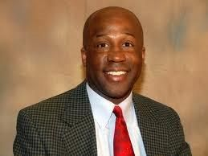

Calvin DuBois Curry was born and raised in North Babylon, New York. He graduated from Saint Paul’s College in Lawrenceville, Virginia, where he lettered in track and was initiated into Omega Psi Phi Fraternity Inc. He also graduated from Averett University with an M.B.A. Rev. Curry has also studied at Shaw Divinity School and Lexington Theological Seminary. He was licensed to preach in 1996 and ordained by the Piedmont Convention Christian Church (Disciples of Christ) in 2008. He is married to the former Lesper Johnson and together they have two children- Winston and Ashton Curry. He is currently serving on the Commission on Evangelism, Membership and Renewal and serves as Vice Moderator for the LACC General Board.

